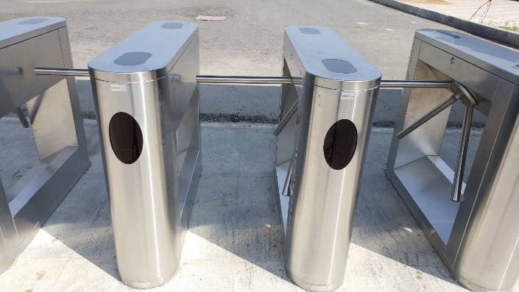
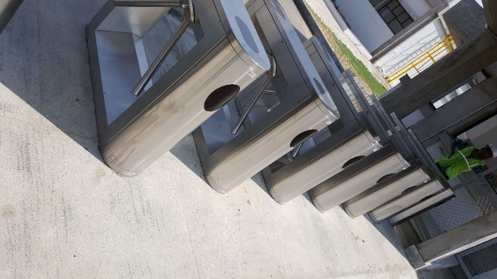

Material | Stainless Steel
Size | 420 x 330 x 980 mm
Rod Length / Thickness | 500 mm / Dia 38 stainless steel tube
Passage width | 600 mm
Motor | 24V/30W brushless
Working Temperature | -40 Degree to 80 Degree
Humidity | 5% to 9%
Opening time | 0.2 Seconds
Passage Speed | 30 peoples/minute

